PERSONAL PROFILE
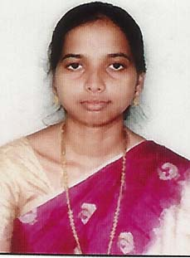oto

Name : KAMBHAM SNEHA LATHA
Designation : LECTURER IN COMMERCE
College Address : SRR & CVR GDC (A) - VIJAYAWADA
Cell No : 8309751486
Mail Id : smily.slicy@gmail.com

Educational Qualifications
S.NO | COURSE | BOARD / UNIVERSITY | YEAR OF PASS | PERCENTAGE
01 | M.Com | Acharya Nagarjuna University - Guntur | 2005 | 63
02 | B.Ed | Acharya Nagarjuna University - Guntur | 2006 | 63
03 | B.Com | Acharya Nagarjuna University - Guntur | 2003 | 56
04 | Intermediate | Board of Intermediate Education | 2000 | 70
05 | SSC | Board of Secondary Education | 1998 | 59
Professional Experience:
- Worked as Lecturer in Commerce from 2007 to till the date.
Conferences at National Level:
- Presented a research paper entitled “A Model of Green Bank Marketing” at a UGC- Sponsored National Seminar conducted by Department of Commerce, SRR & CVR GDC (A) College, Vijayawada on 23th – 24th January, 2018.
Workshops attended
- Participation in One Day Workshop on "Entrepreneurship Development" conducted by Department of Commerce, SRR & CVR GDC (A) College, Vijayawada on 30-10-2015.
- Participation in One Day Workshop on "Integral Economic Thought - Humanism" at a UGC- Sponsored National Seminar conducted by Department of Economics, Journalism & Sociology, SRR & CVR GDC (A) College, Vijayawada on 14th July, 2016.

